# REACH-spouse logo of clasping hands with a teal background.

# REACH-Spouse Facilitator Instructions

RESOURCES EXIST, ASKING CAN HELP- SPOUSE

Dear REACH-Spouse Facilitators,

Thank you for your interest in the Resources Exist, Asking Can Help-Spouse (REACH-Spouse) curriculum!

REACH-Spouse is designed to encourage military spouses to seek resources for themselves and their service member to help address any challenges they may face. We know from prior research that despite the abundance of available support resources for military families, spouses may not know these resources exist or may not be willing to reach out to them. Through REACH-Spouse, we aim to fill this gap by removing barriers to care and helping military spouses get the support they need.

We have created materials for two 2-hour REACH-Spouse standalone sessions:

* Session 1 focuses on **military spouses’** barriers to seeking mental health care, resources for addressing these barriers, and self-care practices.
* Session 2 focuses on the **service members’** barriers to seeking mental health care and teaches military spouses valuable suicide prevention skills.

You will need to review **six key instructional materials** ahead of your session **in the following order,** found on the Military OneSource website**:**

1. Facilitator’s Manual for Active Duty or National Guard/Reserve
2. Resources Handout
3. Demonstration Video
4. REACH-Spouse Session Slide Deck
5. Military Spouse Recruitment Guide
6. Practice Checklist

The rest of these instructions describe each of these instructional materials in detail. We hope you enjoy the learning journey and find great meaning in being a REACH-Spouse facilitator!

Sincerely,

The REACH-Spouse Team

Version 3, March 2024 (OPA-2021-035, PERSEREC-PA-20-21)

## Facilitator’s Manual

The **Facilitator’s Manual,** shown in Figure 1, is the most essential document, as it lays out the overall goals of the REACH-Spouse program, gives step-by-step instructions for how to lead REACH-Spouse sessions, contains sample talking points, and provides additional resources for both facilitators and spouse participants.

**Figure 1: Cover Page of the Active Duty REACH-Spouse Facilitator’s Manual**

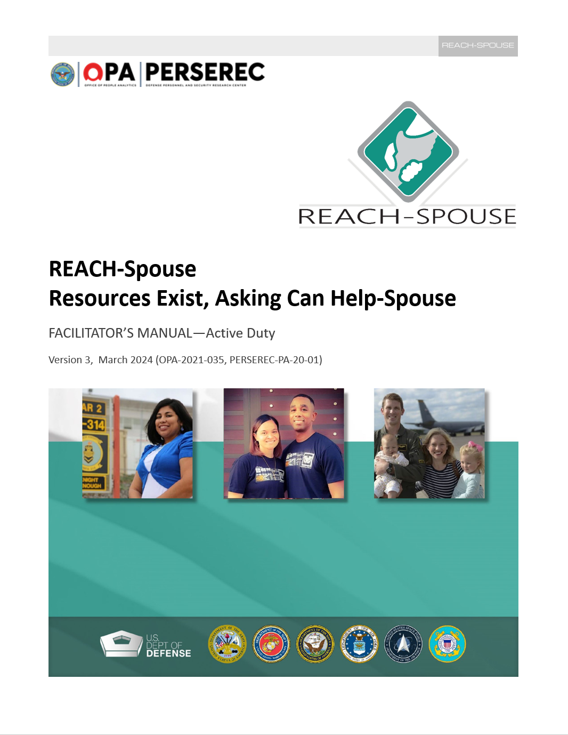

Sections 1-7 explain the goals and rationale behind REACH-Spouse and discuss the role of the REACH-Spouse facilitator. This portion of the manual also describes the basic components of each REACH-Spouse session and teaches facilitators Motivational Interviewing basics.

Section 8 covers logistics and includes steps for how to prepare to lead a successful REACH-Spouse session. It also contains a detailed session agenda and a checklist of actions you should complete before, during, and after your session. This checklist also explains how long you should expect to spend on each section or slide. In total, your session should last approximately 2 hours.

Section 9 displays the slides you will use in your REACH-Spouse session. Each slide has a list of main discussion points that you will be asked to cover. Each slide also contains detailed talking points identified by the words “CUE”, “SAY,” “ASK,” and “TIP” (see Figure 2). We encourage you to personalize these talking points and use your own words as much as possible, but not deviate too much from the original text. Follow your intuition and experience and come up with your own natural way of introducing the material, while keeping in mind the purpose of each slide.

## Facilitator’s Manual, *cont.*

**Figure 2: “Cue,” “Say,” “Ask,” and “Tip” Examples**

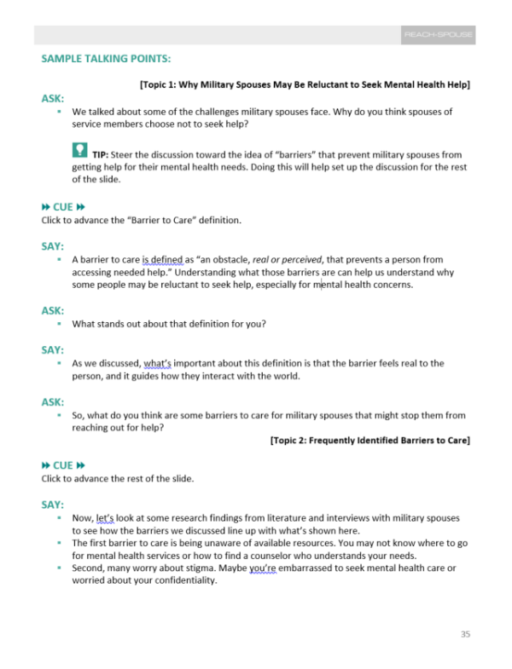

As a facilitator, one of your responsibilities is to engage with your audience in a meaningful way and to make them feel comfortable engaging with you. *Appendix B* of the manual contains Motivational Interviewing principles and techniques, which are designed to help you build a rapport with your audience and establish a positive environment in your session.

During your REACH-Spouse session, you will make a practice phone call to Military OneSource together with your participants (see Figure 3). This hands-on exercise is designed to demonstrate to military spouses how easy it is to call this resource for help with any of their or their service member’s military life-related problems, and to build up their confidence about using Military OneSource in the future. The manual contains an example script for you to follow when you make the call. Previous studies have found that the act of contacting a supportive resource is incredibly difficult for some people, and having a live demonstration can help people overcome their anxiety and even counteract prior negative experiences. Please review the script ahead of the session and practice making the call at least once with a friend or family member.

## Facilitator’s Manual, *cont.*

**Figure 3: Practice Call to Military OneSource**

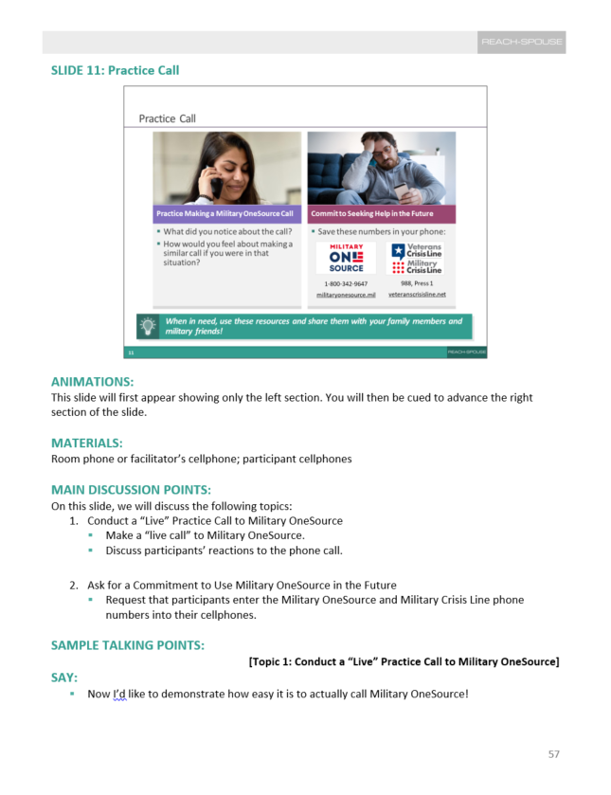

## Resources Handout

The **Resources Handout,** shown in Figure 4, is designed to connect your participants with national and local resources available to military spouses, service members, and their dependents. These resources are grouped into six major categories: 1) Mental Health Resources; 2) Sexual Assault, Abuse, and Prevention Resources; 3) Employment Resources; 4) Service Branch Resources; 5) Social Media, Video, and Mobile Resources; and 6) Other Important Resources.

**Figure 4: Resources Handout**

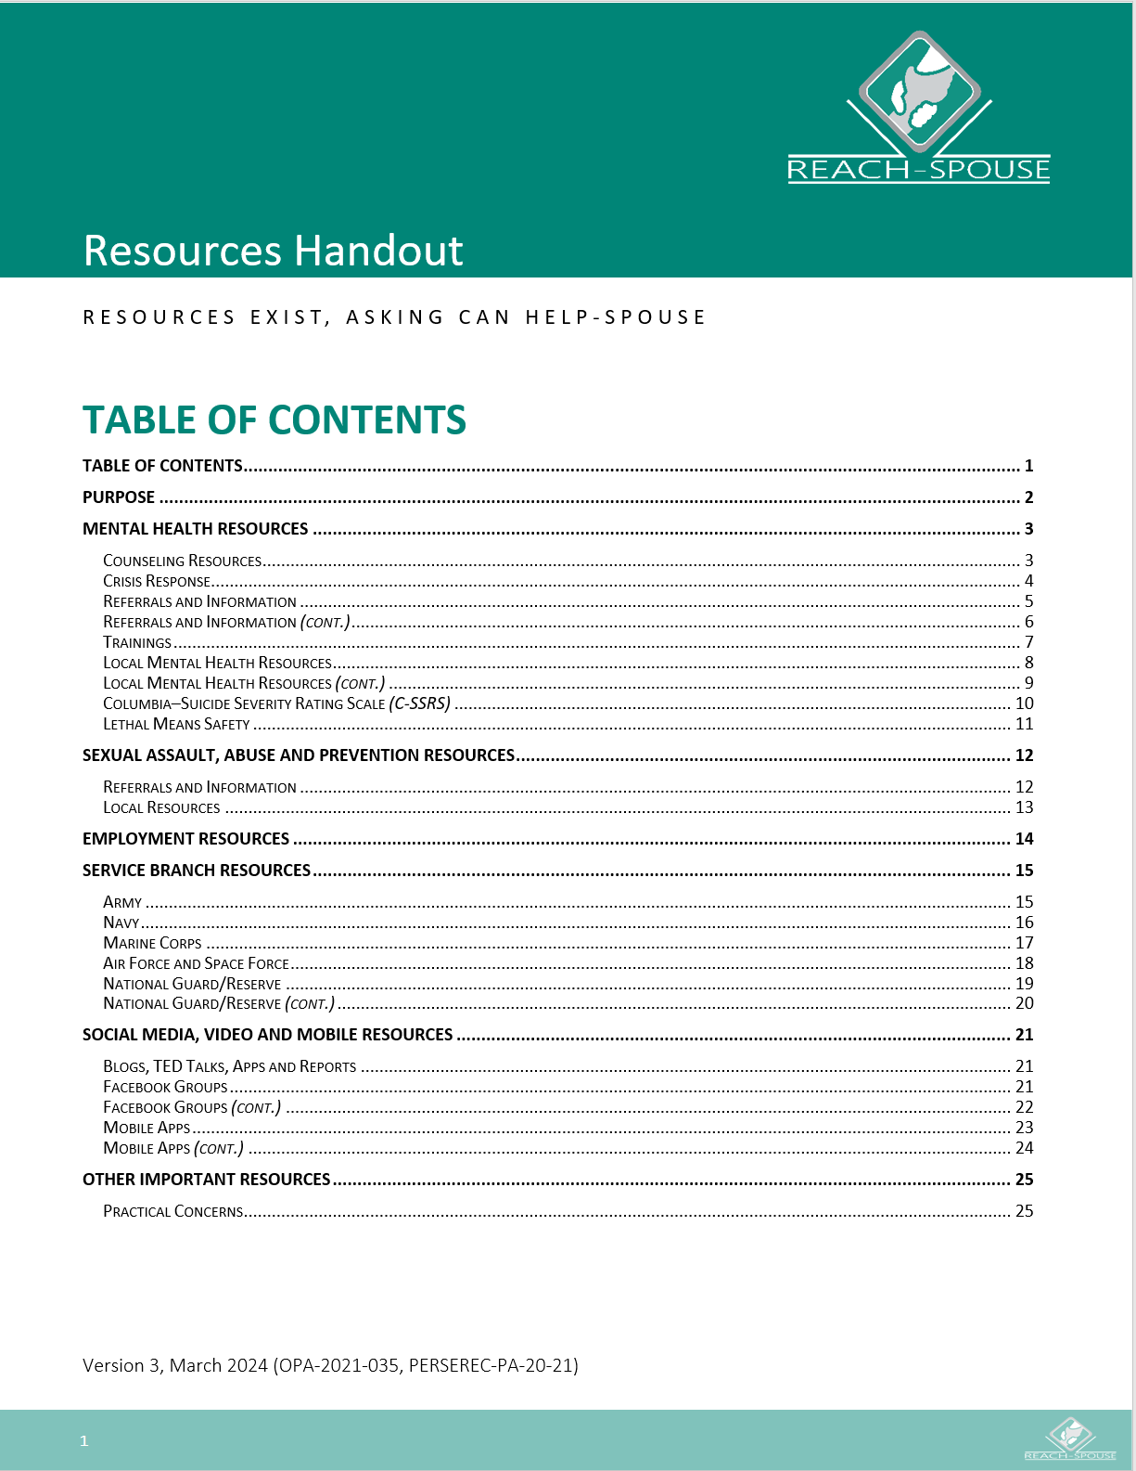

## Resources Handout, *cont.*

Note that there is also some homework that you will need to complete prior to your REACH-Spouse session. The Resources Handout currently has yellow highlighted areas that act as placeholders for resources local to your community, installation, or command (see Figure 5). Prior to the session, we ask that you identify resources applicable to your target audience and populate these sections. *Appendix D* of the Facilitator’s Manual provides helpful tips for how to research and identify local resources. Once you fill in the local resources in the handout, print out hard copies to distribute to your participants at the end of the REACH-Spouse session, or e-mail it to them afterwards.

**Figure 5: Example of Highlighted Areas**

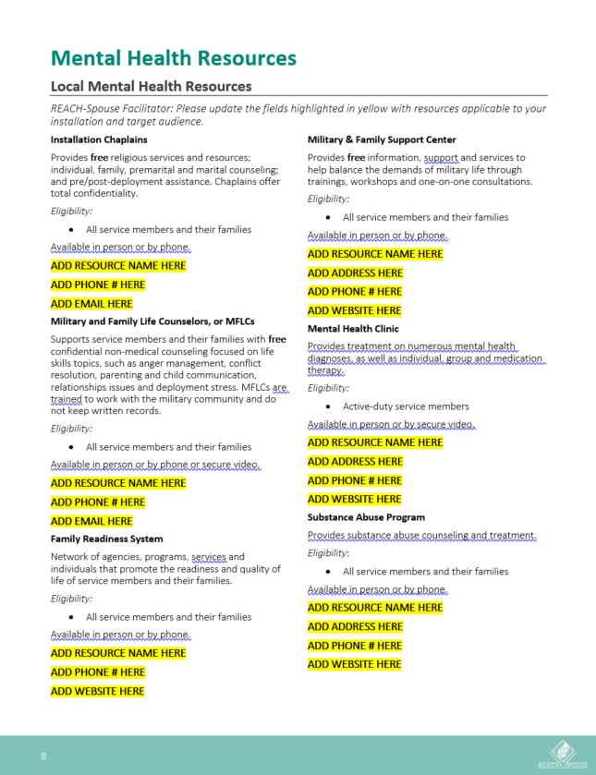

## Demonstration Video

The **Demonstration Video,** shown in Figure 6, is a 90-minute recording that features a sample full-length REACH-Spouse session designed to serve as an example for other facilitators. *Please note that even though this video is 90 minutes long, we still recommend scheduling your REACH-Spouse sessions for 2 hours based on prior field testing.* Although there are two demonstration videos for REACH-Spouse Sessions 1 and 2, respectively, you would only need to watch the one corresponding to the session you will be leading. Session 1 video addresses overcoming barriers, finding resources, and thriving as a military spouse. Session 2 video focuses on supporting service members’ mental health and well-being. Both videos are a great example of how to use Motivational Interviewing to build rapport with your participants and elicit engagement. The facilitator not only moves through the slide deck in accordance with the Facilitator’s Manual, but also answers difficult questions from participants.

We suggest that you review these 90-minute demonstration videos with the Facilitator’s Manual on hand and follow along slide-by-slide.

**Figure 6: Session 1 Demonstration Video**

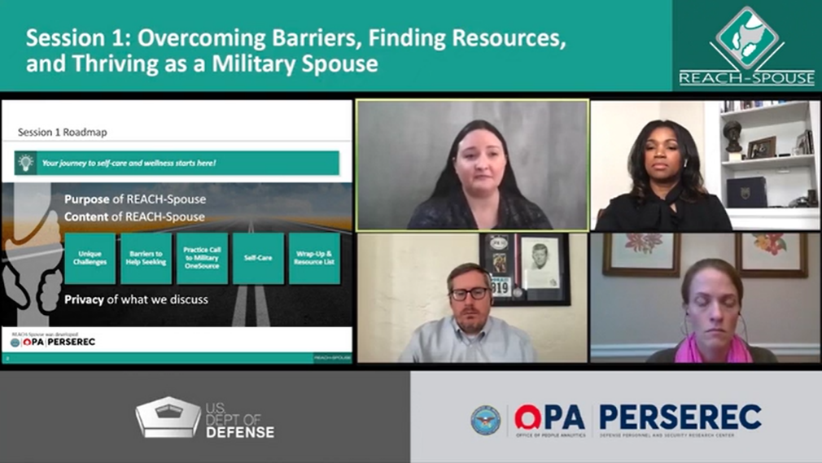

## REACH-Spouse Session Slide Deck

The **REACH-Spouse Session** **Slide Deck,** shown in Figure 7, is another document you will need to review in preparation for your REACH-Spouse session. Session 1 consists of 14 slides, whereas Session 2 consists of 15 slides. Please note that there are separate slide decks for Sessions 1 and 2, and for active duty and reserve component military spouses.

We recommend that you practice for your session using the slide deck to pace yourself through the major discussion points and be optimally prepared. Plan on displaying the slide deck during your REACH-Spouse session if you have access to a computer screen or overhead projector. You may also email or print out the slides for participants, so they can follow along. Be sure to update the first slide with your name, location, and session date.

**Figure 7: REACH-Spouse Session 1 Slide Deck**

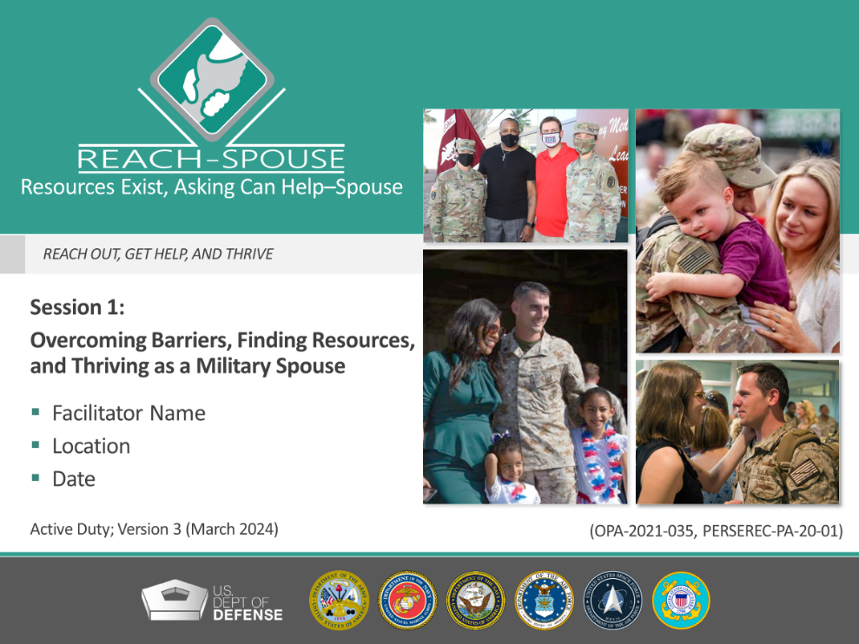

## Military Spouse Recruitment Guide

If you are not sure where to start with recruitment, we’ve put together a **Military Spouse Recruitment Guide** with some helpful tips and strategies, draft social media posts, and a recruitment flyer for you to use (see Figure 8). Feel free to personalize these materials as much as needed. The optimal group size for a REACH-Spouse session is 10 participants, with a minimum of 5 and a maximum of 15. We suggest that you lean on your existing social networks via word of mouth, social media, email chains, and text messages to assist with recruitment.

**Figure 8: Military Spouse Recruitment Guide**

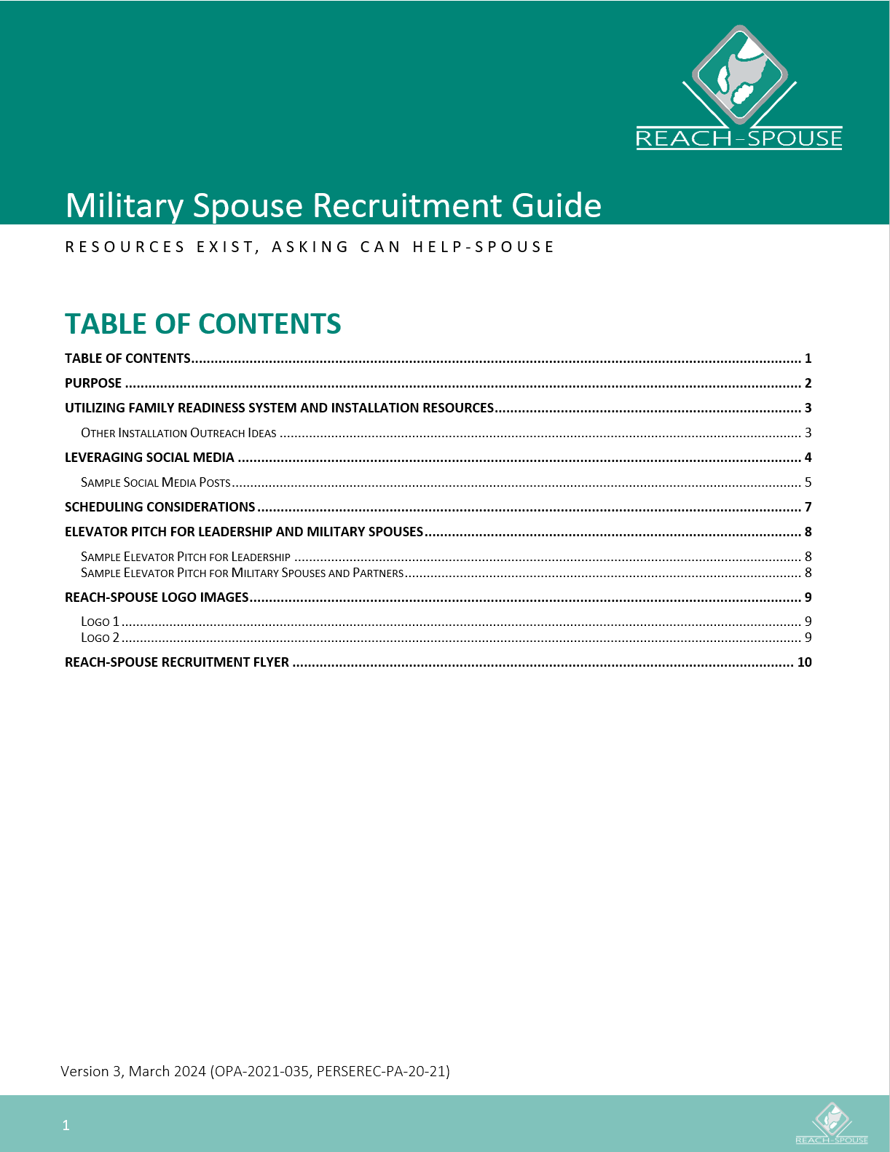

## Practice Checklist

Once you have had a chance to review the Facilitator’s Manual and are ready for some practice, we have created a **Practice Checklist** to assist you with this task. This document contains a list of main points you will need to cover on each slide, as well as some tips and reminders to help you as you go along. Consider practicing with a friend, family member, or a coworker and having them consult the checklist as you practice the slides, so that they could give you feedback after each slide. This checklist will also help you with pacing yourself, as it shows roughly how much time you should spend on each slide.

**Figure 9: Practice Checklist**

